**6.1.2023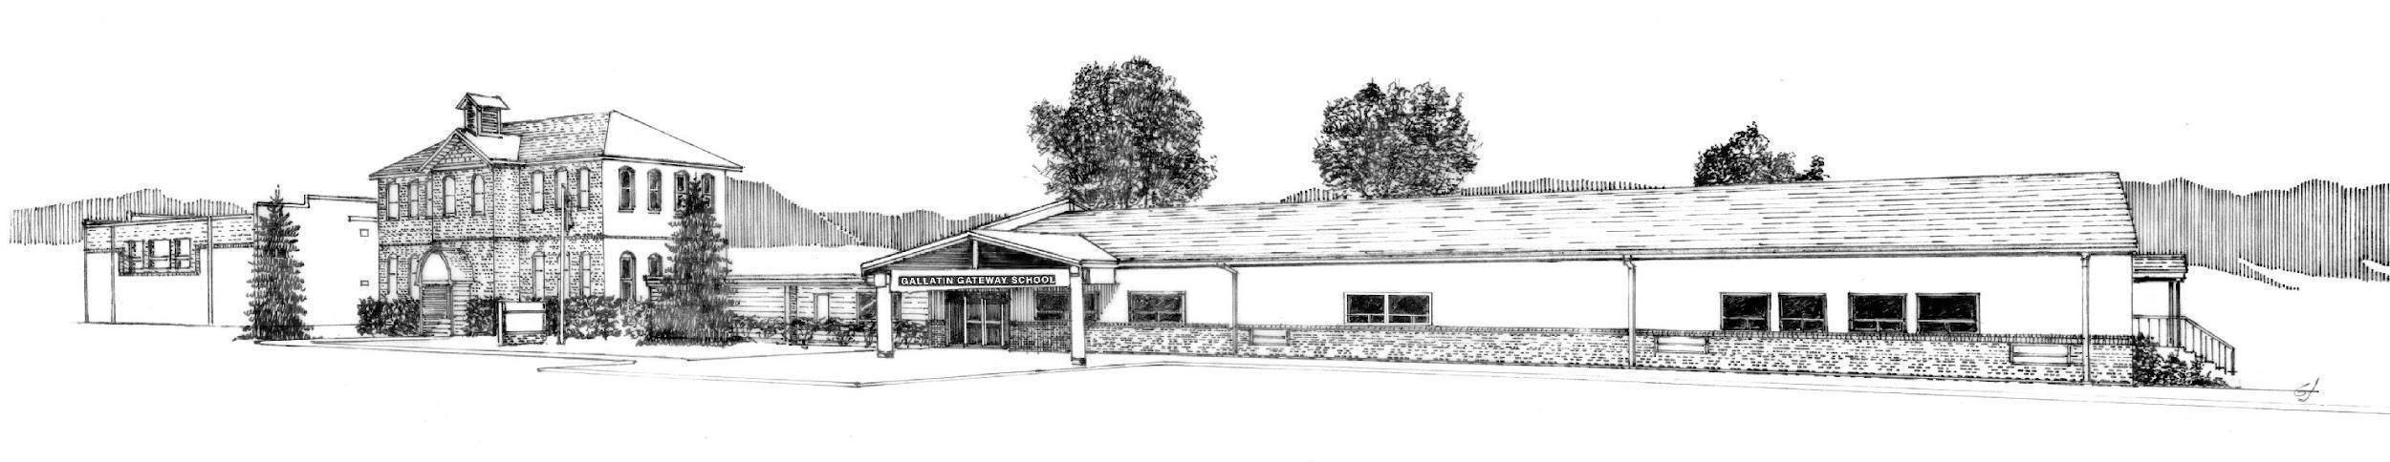 Agenda**

**Special Meeting of Trustees**

The special meeting of the Board of Trustees of School District #35 has been scheduled for **June 1, 2023** at **9:00 A.M.** **in the boardroom.**

**Call to Order**

**Public Comment - Non Agenda Items** 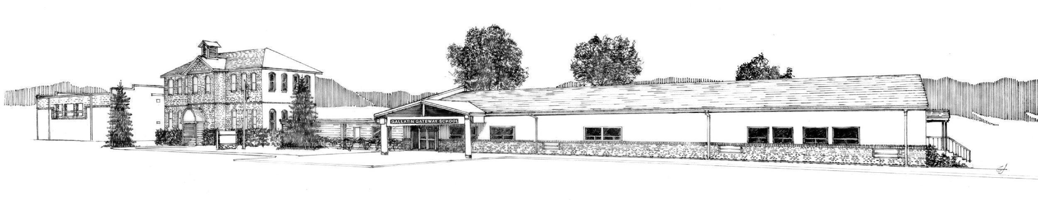

**New Business**

Setting Agenda for Regular Board Meeting

**Next Meetings:**

Regular Meeting - June 21, 2023 @ 6 pm

**Adjournment**